MAIN REFERENCE

<https://www.templatemonster.com/demo/63506.html>

DOMAIN

<https://designingmedia.com/wordpress/hostiko/layout18/>

SOLOGAN

<https://designingmedia.com/wordpress/hostiko/layout18/>

PARTNERS / clients

<https://demo.hasthemes.com/mitech-preview/index-appointment.html>

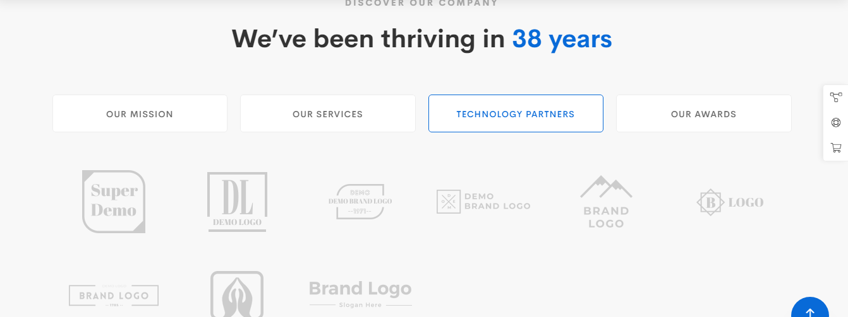

PRICE LIST

<http://iqonic.design/sofbox-vue/landing-page-7>

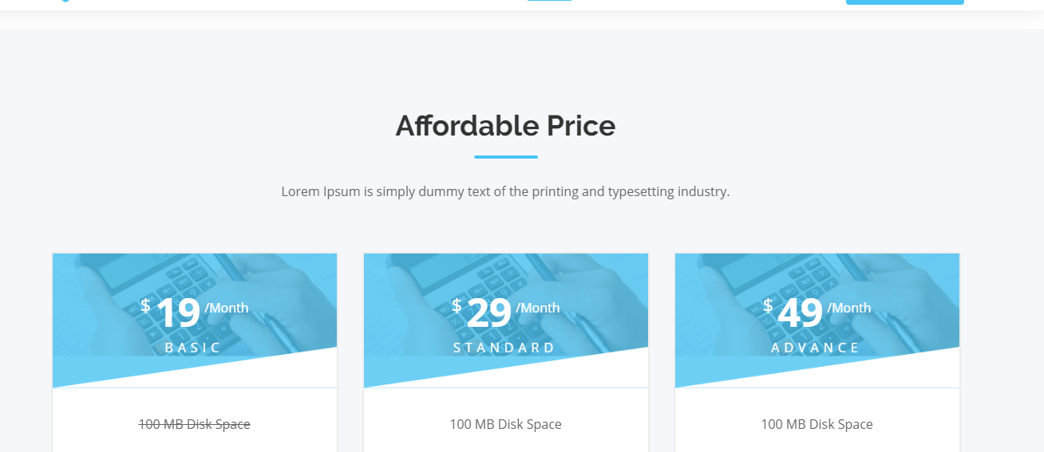

FAQ (done)

<http://iqonic.design/sofbox-vue/landing-page-7>

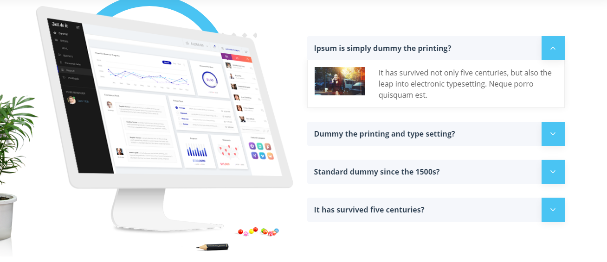

SERVICES SLIDER (done)

<https://demo.hasthemes.com/mitech-preview/index-services.html>

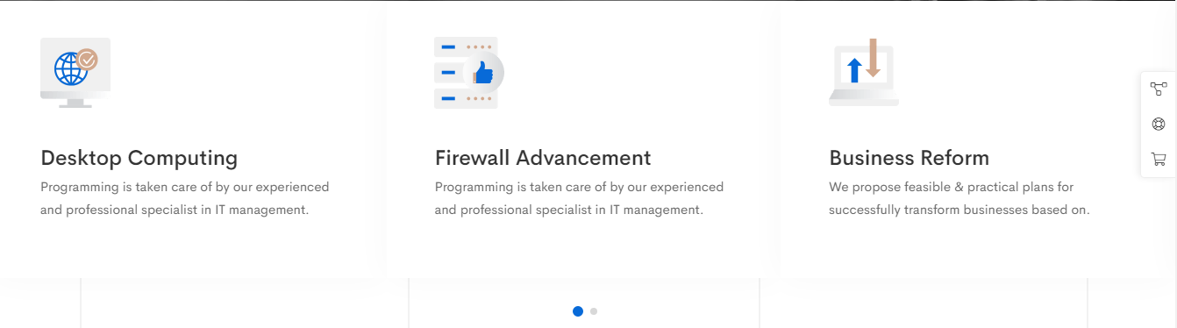

NEWS

<https://demo.hasthemes.com/mitech-preview/index-services.html>

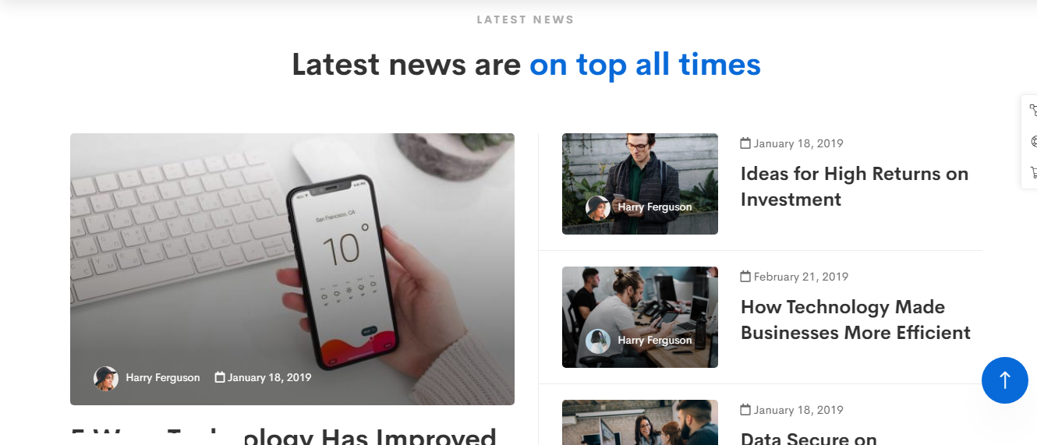

COUNTER

<https://www.templatemonster.com/demo/63506.html>

from main template

AWARDS

<https://demo.hasthemes.com/mitech-preview/index-appointment.html>

PROJECTS

<https://demo.hasthemes.com/mitech-preview/index-appointment.html>

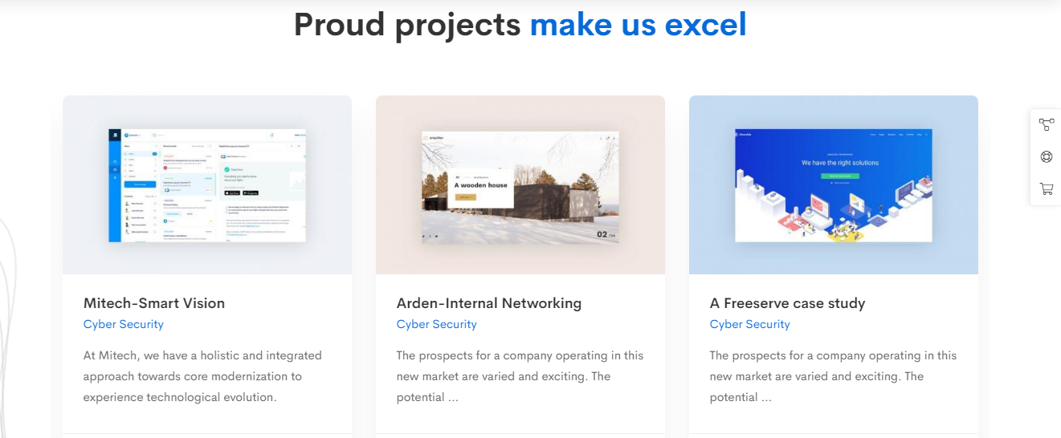

Logo, title, website link

PARTNER & QUOTATION (problematic)

<https://demo.hasthemes.com/mitech-preview/index-appointment.html>